Mohammad Widyarta

Universitas Indonesia

**Wirjoatmodjo, Sujudi (1928-1981)**

Sujudi Wirjoatmodjo was an Indonesian architect whose work helped define a new post-independence identity for Indonesia. His first name is also spelled as *Soejoedi*. He was born in Rembang and died in Magelang. As a student, Wirjoatmodjo was a member of the architecture group ATAP. He founded his office in 1969, the Jakarta-based Gubahlaras Architects (now PT Gubahlaras Arsitek dan Perencana).

In 1951 Sujudi enrolled in Universitas Indonesia’s Faculty of Engineering Science in Bandung (now Institut Teknologi Bandung, or ITB). In 1954, he moved to study at the École des Beaux Arts, Paris. He stayed in Paris only for a year, before moving to the Technische Hogeschool at Delft (now Delft University of Technology). In 1958, he moved to the Technische Universität, Berlin. Upon graduation in 1960, he went back to Indonesia to lead the architecture programme at ITB.

Sujudi designed a number of important works in Indonesia. The Conefo Complex in Jakarta (1964, now the Indonesian Parliament Building, better known as Gedung DPR/MPR) combined modernist ideas with Javanese cosmological concepts. He also designed the Sutami Centre of Hydroelectric Generator, East Java (1969), a rather BRUTALIST work. Other important works are the French Embassy in Jakarta (1969, razed down in 2012 to be replaced), and the Secretariat of Association of Southeast Asian Nations in Jakarta (1978).

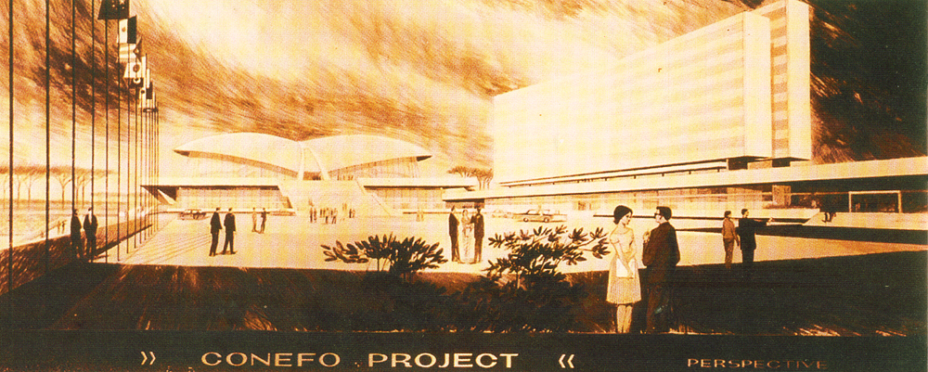

Perspective drawing of Conefo Complex (1964), now known as Gedung DPR/MPR, Indonesia’s parliament building in Jakarta (Source: *Djakarta Through the Ages*).

**List of Works**

1961 Braga Permai Restaurant, Bandung.

1964 Conefo Complex (now the Parliament Building), Jakarta.

1969 Sutami Hydroelectric Centre, Karangkates, East Java.

1969 French Embassy, Jakarta.

1971 Pusat Grafika Indonesia, Jakarta.

1978 Secretariat of Association of Southeast Asian Nations, Jakarta.

1979 Indonesian Embassy, Belgrade, Serbia.

**References and Further Reading**

Ali, M., and F. Bodmer (1970) *Djakarta Through the Ages*, Jakarta: the Government of the Capital City of Djakarta.

Saliya, Y. (2012) “Pagi Hari dan Lekang Siang Seorang Sujudi,” in *Tegang Bentang: Seratus Tahun Perspektif Arsitektural di Indonesia*, Jakarta: Gramedia & Pusat Dokumentasi Arsitektur Indonesia.

Sukada, B. A. (2011) *Membuka Selubung Cakrawala Arsitek Soejoedi*, Jakarta: Gubah Laras.